Oliver Creek Church of Christ
Bartlett, Tennessee
Global Missions

Global Missions Team Members:

Joe McDaniel-Elder
Emmanuel Madu-Deacon
Logan Hollinsaid
Scott Robbins
Pamela Madu
Alex Lopera
Raymond Powell
Cate Lopera
Kathy Cooper

Purpose of the Global Missions
Oliver Creek focuses on making disciples and planting churches. Therefore, Oliver Creek will emphasize mission work that focuses on evangelism, church maturity, and community service domestically and internationally.
Our goal is to make disciples and plant churches domestically and internationally who will gather themselves into eventually self-sustaining churches that continue making disciples and planting other churches. These churches will be expected to mature into self-supporting, self-propagating, and self-edifying churches. In this way the churches will not only sustain themselves, but also execute the work of God into the future.
Supporting Missionaries and Missions
Oliver Creek seeks to support missionaries who are committed to prayer and the power of the Holy Spirit as the starting point for all mission work. A willingness to prepare for the mission as well as an eagerness to train up future leaders for continuity of the work are important qualifications.

Missions/missionaries:
- Those who are long term will be more favorably considered if they address these OC set goals of mission
- Evangelism.
- Church growth, maturing, & unity.
- Community Service.
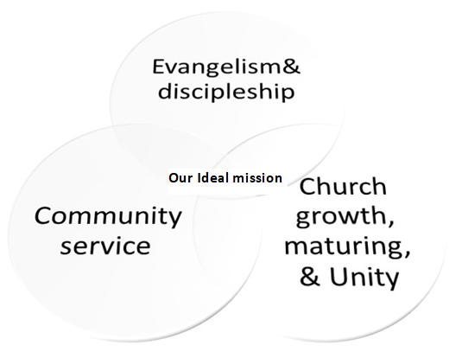

Initial Missionary Application
Please fill out this form as an initial request to be sent out as a missionary by the Oliver Creek Church of Christ. It may be completed in writing, or the same questions answered in an electronic document. Completing this form may result in an interview between you and Oliver Creek’s Global Mission Team. If we mutually decide after such a meeting to take our relationship further, you will be asked to fill out a more extensive inventory (without duplication of information on this form) about your life, experiences, beliefs, and recent history. Information given will be treated confidentially by the GMT and church leaders. If you wish to explain any item(s) personally, please so indicate at the appropriate place.

Pre-accountability interview for long term missionary (and for periodic check-in) and Legacy mission and missionaries
Biographical data
- Name:
- Date of birth:
- Country of origin
- Languages spoken
- What are your skills/training/education?
- Spouse:
- Spouse profession:
- Years of marriage:
- Have you gone through a divorce?
- Members of family and Date of birth:
- Is anyone else in your family a Christian?
- Children’s Profession or school:
- How is your marriage doing (if applicable)?
- What are your skills/training/education that prepares you for this mission work?
- What are your hobbies?
- How is your health?
- Do you have any legal actions pending against you?
- Have you ever committed a serious violation of criminal law, regardless of whether you were arrested, you were convicted, or the record was expunged?
Faith
- Do you share our core bible-based belief based expressed on our webpage-https://www.olivercreek.org/our-beliefs
- Date of your conversion:
- What is your conversion story?
- What is your favorite book of the bible, favorite passage, favorite author?
- Describe your personal walk with God during the past year:
- Name of church you worship with:
- How many years have you been worshipping with the church?
- What is your role in the church?
- Size of church you worship with:
- Does the church you worship with practice acapella worship and complementarian leadership structure?
- How is your faith in God? Share some trials you’ve been through and how you overcame/withstood it.
- Would you be willing to share some things you’re wrestling or struggling with? Questions? Tensions or conflicts in ministry? Sins?
Mission
- Describe the city where mission work is taking place:
- Describe the target group(s) for this mission.
- Who are your current and potential partners in this effort?
- How are you currently serving and accessing the community?
- How long have you been in the mission?
- What is the background of your mission?
- What are some struggles in the field?
- What training do you have for your current mission work?
- Do you currently have, or have you ever had any physical, mental, or emotional condition that would make it difficult for you to maintain a normal missionary schedule?
- How do you plan to tell unbelievers about Jesus and disciple them?
- How do you plan to disciple current members, if applicable?
- Describe in detail how you plan to fulfill our three goals of mission plan-evangelism, church growth, & community service?
- How does your spouse feel about this mission?
- How will your spouse assist you during this mission?
- How has your wife prepared for this mission?
- What plans have you put together for your children
- What is the monthly financial support you are seeking for this mission?
- What other support do you need?
- What is the monthly work fund for this mission?
- What is the purpose of the work funds?
- What is a projected length of the mission?
- Are you seeking or do you currently receive other financial support from somewhere else? If so, where, and how much?
- Do you collaborate with a partner or group? Please explain.
- Are you planning to work with a team of missionaries? If so, are you planning to join a team already established in the country, or are you part of a new team that is planning to go together to the mission field?
- Do you have a specific role on the team? If so, what is it?
- Please tell us about the team: when was it formed, who are on the team, how long have you and the team worked together thus far? Does the team have a goal of how long they will stay on the mission field? Etc.
- Summarize how you have seen God leading and working in specific areas of your life and ministry during the years.
- Explain your vision for ministry in the coming year, including any specific goals you have established.
- What are the needs in your area?
- Share some ministry highlights and reasons for rejoicing from the past.
- Share any ministry disappointments or discouragements from the past.
- Share any specific training skills that you believe you need to be more effectively reach your ministry objectives.
- Please share any insights or ideas that you may have about how we may better serve you spiritually or otherwise
Finances
- How are your finances?
- Please detail the current monthly support commitments to you and your ministry, including both churches and individuals.
- Do you have any unpaid debts?
- What are your plans, if any, if your financial support decreases or stops?
Three references we can contact
- _______________________________________________________________
- _______________________________________________________________
- _______________________________________________________________
Please send completed form to: Global Missions Team Oliver Creek Church of Christ 8313 US-70, Arlington, TN 38002. Phone: (901) 388-2250.

